SENSOR FUSION AND PID CONTROL

FOR QUADCOPTER HOVERING

LIM MING JUN

UNIVERSITI TEKNOLOGI MALAYSIA

PSZ 19:16 (Pind. 1/23)

UNIVERSITI TEKNOLOGI MALAYSIA

DECLARATION OF THESIS

|  |  |  |  |  |  |
| --- | --- | --- | --- | --- | --- |
| Author’s full name | : | LIM MING JUN | | | |
| Student’s Matric No. | : | A20MJ0035 | Academic Session | : |  | | |
| Date of Birth | : |  | UTM Email | : |  | |
| Thesis Title | : | SENSOR FUSION AND PID CONTROL  FOR QUADCOPTER HOVERING | | | |

I declare that this thesis is classified as:

|  |  |  |
| --- | --- | --- |
|  | OPEN ACCESS | I agree that my report to be published as a hard copy or made available through online open access. |
|  |  |  |
|  | RESTRICTED | Contains restricted information as specified by the organization/institution where research was done.  (The library will block access for up to three (3) years) |
|  |
|  |
|  |  |  |
|  | CONFIDENTIAL | Contains confidential information as specified in the Official Secret Act 1972) |

(If none of the options are selected, the first option will be chosen by default)

I acknowledged the intellectual property in the proposal belongs to Universiti Teknologi Malaysia, and I agree to allow this to be placed in the library under the following terms:

1. This is the property of Universiti Teknologi Malaysia
2. The Library of Universiti Teknologi Malaysia has the right to make copies for the purpose of only.
3. The Library of Universiti Teknologi Malaysia is allowed to make copies of this Choose an item. for academic exchange.

|  |  |
| --- | --- |
| Signature of Student: | |
| Signature : | |
| Full Name | |
| Date : | |
|  | |
| Approved by Supervisor(s) | |
| Signature of Supervisor: |  |
| Full Name of Supervisor  SHAHRUM SHAH BIN ABDULLAH (ASSOC. PROF. DR.) |  |
| Date : |  |

NOTES : If the thesis is CONFIDENTIAL or RESTRICTED, please attach with the letter from the organization with period and reasons for confidentiality or restriction

“I hereby declare that I have read this proposal and in my

opinion this proposal is sufficient in term of scope and quality for the

award of the degree of Bachelor of Electronic Systems Engineering (Engineering)”

|  |  |  |
| --- | --- | --- |
| Signature | : | ________________________________ |
| Name of Supervisor I | : | ASSOC. PROF. DR. SHAHRUM SHAH BIN ABDULLAH |
| Date | : | 9 May 2017 |
|  |  |  |
|  |  |  |
|  |  |  |
|  |  |  |
|  |  |  |
|  |  |  |
|  |  |  |
|  |  |  |
|  |  |  |
|  |  |  |

**Pengesahan Peperiksaan**

Tesis ini telah diperiksa dan diakui oleh:

|  |  |  |
| --- | --- | --- |
| Nama dan Alamat Pemeriksa Luar | **:** |  |
|  |  |  |
|  |  |  |
|  |  |  |
|  |  |  |
| Nama dan Alamat Pemeriksa Dalam | **:** |  |
|  |  |  |
|  |  |  |
|  |  |  |
|  |  |  |
| Nama Penyelia Lain (jika ada) | **:** |  |
|  |  |  |
|  |  |  |
|  |  |  |
|  |  |  |

Disahkan oleh Timbalan Pendaftar di Fakulti:

|  |  |  |
| --- | --- | --- |
| Tandatangan | : |  |
| Nama | : |  |
| Tarikh | : |  |

SENSOR FUSION AND PID CONTROL

FOR QUADCOPTER HOVERING

LIM MING JUN

A proposal submitted in partial fulfilment of the

requirements for the award of the degree of

Bachelor of Electronic Systems Engineering (Engineering)

Malaysia-Japan International Institute of Technology

(MJIIT)

Universiti Teknologi Malaysia

8 JANUARY 2023

DECLARATION

I declare that this proposal entitled *“Sensor Fusion and PID Control for Quadcopter Hovering”* is the result of my own research except as cited in the references. The proposal has not been accepted for any degree and is not concurrently submitted in candidature of any other degree.

|  |  |  |
| --- | --- | --- |
| Signature | : | .................................................... |
| Name | : | LIM MING JUN |
| Date | : | 8 January 2024 |
|  |  |  |
|  |  |  |

ACKNOWLEDGEMENT

I would like to give my greatest gratitude towards my supervisor, Assoc. Prof. Dr. Shahrum Shah Bin Abdullah for guidance and support throughout my preparation of this proposal. Dr. Shahrum had not only provided me with the necessary study materials, but also provided me with a room with all the microcontrollers, electronic components, test instruments, and tools that were well maintained and working at its top conditions. Dr. Shahrum also conducted RinKoh session and checks my progress from time to time.

Besides, I would also like to express my appreciation towards my Senpai (senior), Ms. Wong Pui Ching, who is a PhD student under the supervision of Dr. Shahrum had given me a lot of suggestion and tips when doing literature review. With her help, I managed to do my literature review efficiently and effectively.

Finally, I would be remiss in not mentioning my family, my lecturers and my friends for their love and support which had allowed me to work on my Final Year Project flawlessly without any side worries.

ABSTRACT

The purpose of this project is to control the hovering height of a quadcopter by using sensor fusion algorithm with the help of a PID Controller. Sensor Fusion is a method of combining two or more sensors to measure the required data or variable. In the early days,

ABSTRAK

Lorum Ipsum

TABLE OF CONTENTS

|  |  |  |
| --- | --- | --- |
|  | TITLE | PAGE |

DECLARATION iii

ACKNOWLEDGEMENT v

ABSTRACT vi

ABSTRAK vii

TABLE OF CONTENTS viii

LIST OF TABLES x

LIST OF FIGURES xi

LIST OF ABBREVIATIONS xii

LIST OF SYMBOLS xiii

LIST OF APPENDICES xiv

CHAPTER 1 INTRODUCTION 1

1.1 Research Background 1

1.1.1 Sensor Fusion 2

1.1.2 UAVs Positioning an Orientation 4

1.2 Problem Statement 5

1.2.1 Limitation in Single Sensor Model 5

1.2.2 Limitation of Single Sensor Model on a Quadcopter 5

1.3 Research Objective 6

1.4 Research Scope and Limitations 7

1.5 Research Significance 7

1.6 Proposal Outline 7

CHAPTER 2 LITERATURE REVIEW 9

2.1 Introduction 9

2.1.1 Sensor Types 9

2.1.2 Sensor Fusion Algorithm 11

2.1.3 Quadcopter Assembly 14

2.2 Research Gap 15

2.3 Summary 15

CHAPTER 3 RESEARCH METHODOLOGY 19

3.1 Introduction 19

3.1.1 Proposed Method 19

3.1.1.1 Research Activities 19

3.2 Tools and Platforms 19

3.3 Chapter Summary 19

CHAPTER 4 PRELIMINARY RESULTS & ANALYSIS 20

4.1 The Big Picture 20

4.2 Analytical Proofs 20

4.3 Result and Discussion 20

4.4 Chapter Summary 20

CHAPTER 5 CONCLUSION 21

5.1 Research Outcomes 21

5.2 Contributions to Knowledge 21

5.3 Future Works 21

REFERENCES 22

LIST OF TABLES

|  |  |  |
| --- | --- | --- |
| TABLE NO. | TITLE | PAGE |

Table 5.1 Example Repeated Header Table 17

LIST OF FIGURES

|  |  |  |
| --- | --- | --- |
| FIGURE NO. | TITLE | PAGE |

Figure 3.1 Example of Formatting Method 12

Figure 4.1 This is MZJ original idea 13

Figure 4.2 The method for hig performance formatting 14

LIST OF ABBREVIATIONS

|  |  |  |
| --- | --- | --- |
| UAVs | - | Unmanned Aerial Vehicles |
| Vlog | - | Video Blogging |
| USA | - | United States of America |
| GPS | - | Global Positioning System |
| IMU | - | Inertia Measurement Unit |
| IR | - | Industrial Revolution |
| PID | - | Proportional-Integral-Differential |
| MSHIF | - | Multi-source and heterogeneous information fusion |
| EKF | - | Extended Kalman’s Filter |
| UKF | - | Unscented Kalman’s Filter |
| CNN | - | Convolutional Neural Network |
|  |  |  |
|  |  |  |
|  |  |  |
|  |  |  |
|  |  |  |
|  |  |  |
|  |  |  |
|  |  |  |
|  |  |  |
|  |  |  |
|  |  |  |
|  |  |  |
|  |  |  |
|  |  |  |
|  |  |  |
|  |  |  |
|  |  |  |
|  |  |  |

LIST OF SYMBOLS

|  |  |  |
| --- | --- | --- |
| dof | - | Degree of Freedom |
| D/d | - | Dimensional |
|  |  |  |
|  |  |  |
|  |  |  |
|  |  |  |
|  |  |  |
|  |  |  |
|  |  |  |
|  |  |  |
|  |  |  |
|  |  |  |
|  |  |  |
|  |  |  |
|  |  |  |
|  |  |  |
|  |  |  |
|  |  |  |
|  |  |  |
|  |  |  |
|  |  |  |
|  |  |  |
|  |  |  |
|  |  |  |
|  |  |  |

LIST OF APPENDICES

|  |  |  |
| --- | --- | --- |
| APPENDIX | TITLE | PAGE |

# INTRODUCTION

## Research Background

With the technology of automation being widely promoted to not only industry, but also commercial use, real time data is becoming the most important part of every piece of devices that wishes to implement automation. From small robots to ‘smart-cities’(Chu & Cetin, 2022), automation is inevitable the life human are living. Studies also found that automation does not cause people to lose their job, but instead increased the opportunity(Manuel, 2020, February 17). From Figure 1.1, it is clear that the estimated growth of market for autonomous vehicle will be growing exponentially. In other words, the reliability towards sensor for its accuracy is crucial especially for maneuvering objects like vehicles, trains, aircrafts, rockets, etc. that requires high demand for safety and low latency.

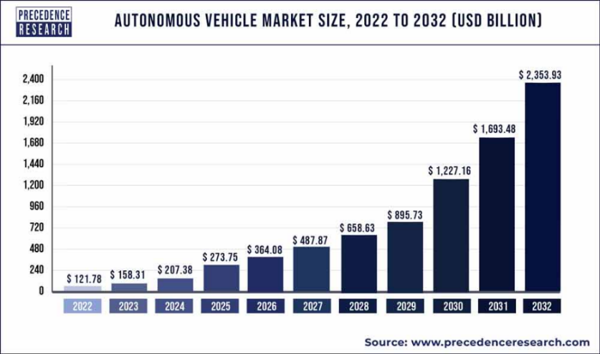

Figure 1.1 Autonomous Vehicle Market

(precedenceresearch.com)(Research, 2022)

As mentioned, automations are not just widely used for industrial application, but also for various commercial use like Quadcopter or Drone Technology. In the early days, Unmanned Aerial Vehicles (UAVs) were developed by the United States of America (USA) during the first world war(IWM, n.d). Recently, with the advancement of social media networking and the increasingly population of video blogging (Vlog), Drones are not only being used for military spying purposes, but also used for photography and videography that allows cinematic shots to be taken above in the air where human cannot reach. No matter if it is for military or videography purposes, the UAVs should have sensors integrated in it to improve control and stability.

Ideally, UAVs is expected to have the ability to fly as high as possible and with great agility. However, sensors even until today may not have the ability to cover the desired range of detection of the UAVs or it may be too overly priced. Hence, engineers had come out with a solution called ‘Sensor Fusion’.

### Sensor Fusion

Sensor Fusion is a method of integrating two or more sensors into a hardware used for detecting the parameter of a particular object that can originally be done with only one sensor(Sasiadek, 2002). However, using multiple sensors for detection provides many advantages compared to only using single sensing modality such as:

1. Increasing Quality and Reliability of Measured Data
2. Provides Estimations to Parameters Outside Sensor’s Sensing Ability
3. Increase Coverage Area of Sensor

The sensors used for sensor fusion can be the fusion of the exact same type of sensor placed at different location. An example for this type of sensor is the modern ‘Bird View 360 Surround Parking Sensor’. This type of sensor uses 4 cameras placed at 4 different corners of the car. Each camara is responsible to capturing their surrounding within their coverage area and then all 4 camera combines their data to form a single 2D view around the car. Figure 1.2 shows the processed image from a bird eye view camera.

Sensor Fusion can also be a combination different sensor to measure one single parameter. An example for this is the position sensing for UAVs. Normally, Global Positioning System (GPS) sensor is used for position tracking. However, GPS Sensor has a downside when it comes to accuracy or when the GPS signal is blocked by obstacle. Hence, an Inertia Measurement Unit (IMU) is normally used together with a GPS to overcome the issues mentioned.

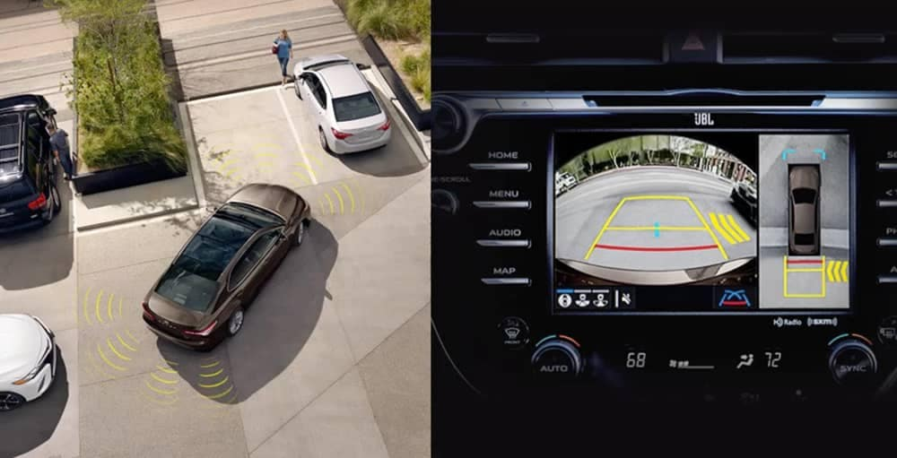

Figure 1.2 Bird Eye View Sensing

(Source: toyotaofnaperville.com/toyotabirdseye-camera-with-perimeter-scan)

Some other cases of Sensor Fusion are implemented for the sake of overcoming unexpected or unavoidable scenarios that may pose safety issues to the user. An example for this is the pitot tube on an aircraft that is used to measure fluid flow velocity. Most Boeing 737 aircrafts have 5 pitot tubes all around it and are used simultaneously and the data collected are processed for a high accuracy measurement. Sensor Fusion plays an important role when one of the sensors is not functioning especially then the aircraft is at a high cruising altitude and the surrounding temperature is lower than the operating temperature of the sensor.

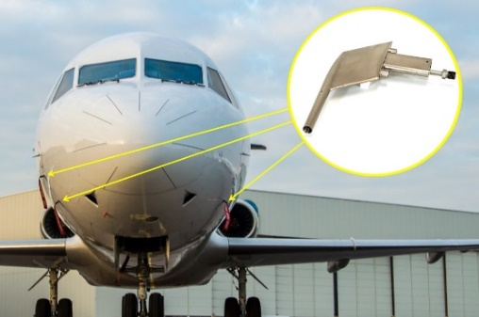

Figure 1.3 Pitot Tube on Aircraft

(Source: Tokyo Aircraft Instrument Co.,LTD.)

### UAVs Positioning an Orientation

A vehicle on land could have 3 degrees of freedom (dof) including forward-back, left-right, and rotation around the z (vertical) axis. This is due to the fact that a land vehicle is designed to only move around in a 2D (not considering going up/down hill) space which is the land. However, for the case of UAVs, they are hovering in mid-air which gives them the ability to move around in a 3D space. The additional dimension allows them to move with 6 dof including forward-back, left-right, up-down, pitch, yaw and roll as shown in Figure 1.4.

|  |  |
| --- | --- |
| undefined  (a) | undefined  (b) |

Figure 1.4 The 6-Dof of an Object in 3D Space

(a: By Horia Ionescu - I (Horia Ionescu) created this work entirely by myself., Public Domain, https://commons.wikimedia.org/w/index.php?curid=10878582 and b: By Yaw_Axis.svg: Auawisederivative work: Jrvz (talk) - Yaw_Axis.svg, CC BY-SA 3.0, https://commons.wikimedia.org/w/index.php?curid=9441238)

Pitch is the elevation or depression of the nose of an object. Yaw is the side-by-side movement of the object horizontal with the ground. Roll is the circular motion of the body in the axis of the nose. The angle of all three rotation is described using the right-hand rule.

## Problem Statement

With the promotion of Industrial Revolution (IR) 4.0 and the latest 5G network technology, governance body as well as some corporates are now in the golden era for developing automated technology, in which all machines or devices are able to collect data from the physical world and make its own decision for the best performance. The trend of passing decision-making from human to machines had significantly reduced the workload on human being especially for repetitive work and had proven to be giving less error compared to human operation(Herbert, 2023). As machines such as UAVs which includes quadcopter or drones are given more and more reliability on their decision making, their ability to detect different parameters in the surrounding is becoming crucial especially when it comes to safety.

### Limitation in Single Sensor Model

Simply relying on one single sensor to detect one or many parameter (e.g. like the DHT22 sensor to detect both humidity and temperature sensor) may be a convenient solution for engineers as it is easy to design and reduces the cost of production. However, when it comes to data reliability is taken at the highest priority, single sensor device is definitely not the best solution the taken into consideration. This is due to the fact that all sensors have their limitation in every way including: Detection Coverage, Operating Conditions, Latency, Power Consumption, etc. Some sensors are able to measure a parameter with very high accuracy but is very susceptible to noise and interference. Meanwhile there are other sensor that are less vulnerable to noise but is not as high in accuracy. Furthermore, there are certain conditions where the operating conditions of the machine may cause the sensors to fail. With the single sensor approach, the machine will fail to operate as soon as the sensor fails. This is a cause of a serious hazard if the machine is a UAV that is flying mid-air.

### Limitation of Single Sensor Model on a Quadcopter

Due to the relatively high number of dof, maintaining good stability for quadcopters is a big challenge compared to normal on ground vehicle which only have 3 dof. All 6 dof for a quadcopter including the 3-axis of movement (x, y, z) and the 3-types of rotation (pitch, yaw, roll) are required to have good stability in order for the quadcopter to operate seamlessly. If a single sensor model is applied for the quadcopter, any failure to any parts of the sensor will cause the quadcopter to lose stability and thus causing a serious safety hazard. Besides, in the case of a quadcopter, it is difficult to decide if we wanted a sensor with high accuracy but susceptible to noise or a sensor less susceptible to noise but high latency. This is because, normally quadcopter is expected to have high latency as any slight delay for a quadcopter moving at high speed may cause it to crash into obstacle. However, quadcopters also could not afford to receive noisy signals as the stability of a quadcopter are normally controlled by a (Proportional-Integral-Differential) PID controller, and any small change in signal will be amplified by the P-part of the PID Controller.

## Research Objective

This project aims to implement multiple sensors for the detection and the controlling of the height of the quadcopter. The objectives of the project are:

1. To compare the performance of using single sensor versus using sensor fusion with different sensor combination to measure the hovering height of the quadcopter.
2. To design and assemble a quadcopter using self-made frame, brushless motor, microcontroller chip and different electronic component.
3. To control the height of a quadcopter based on the desired (user) input using a PID Controller.

After this project, a simple quadcopter with 4 propellers will be constructed with multiple sensors integrated in it to measure the height of the quadcopter from ground truth that is controlled with a PID controller programmed from a microcontroller.

## Research Scope and Limitations

This project focuses on the implementation of sensor fusion method to determine the hovering height of a quadcopter. This includes understanding and selecting the types of sensors to be used so that they all could overcome the weaknesses of each other. Besides, it also includes implementing the suitable type of sensor fusion algorithm that works best for both sensor fusion performance and hardware capability. The knowledge of assembling up hardware will also be discussed slightly in this project, which includes the understanding the orientation of propellers, programming the microcontroller into a PID Controller and connecting all components into one piece. It is also to note that only the up-down (height) motion of the quadcopter will be taken into consideration for this project.

Keywords: Sensor Fusion, PID Controller, Quadcopter, Height

## Research Significance

Previously, engineers were required to rely on their experience and do the ‘give and take’ decision to decide which sensor are suitable for their application. With this project, engineers may choose to use both or more sensors based on their needs by using sensor fusion method.

## Proposal Outline

The following parts of this proposal is structured into several chapters. This first chapter, which is this current chapter gives an overview of what the whole proposal is working on. In the second chapter, some relevant literatures and research will be included and the research gap will be determined. Next in the third chapter, the step-by-step process of realizing the project will be discussed. Then in the fourth chapter, some of the preliminary results from computer simulation will be included to visualize the expected outcome before working on the actual hardware. Finally, the fifth chapter will conclude all the proposed idea of this project.

# LITERATURE REVIEW

## Introduction

Many quadcopters or more commonly known as ‘Drones’ that have been used for professional use or even commercial use have various sensors integrated into it for different purposes especially on localization and positioning. Due to the fact that drones are free to move at all directions in the 3D space its stability is the major challenge when designing it. Although drones nowadays have sensors integrated to it, the sensors may be prone to noise and disturbance like the vibration from the drone motors. Hence, engineers had came up with a solution of using multiple sensor fusion technique to ensure a good quality sensor data.

This chapter will show some of the studies done on sensor fusion techniques including the types of sensors that are suitable for different scenarios and the optimum sensor fusion algorithm which is good enough to obtain a good sensor data but not to computational heavy that is too powerful for a basic controller.

### Sensor Types

(Alatise & Hancke, 2020) had made a study on different sensor combination used for autonomous mobile robot sand classified different types of sensors systems based on their functionalities. The class of sensors classified are: Tactile Sensors, Wheel Encoders, Optical Sensors, Heading Sensors, Vision-Based Sensors and Active Ranging Sensors. The summary of description of the different classes of sensors and its relation to our project is shown in Table 2.1. Among the 6 classes, only 3 will be taken into consideration for our project which are tactile sensors, optical sensors and active ranging sensors.

Table 2.1 Sensor Class and Relation to Project

|  |  |  |  |
| --- | --- | --- | --- |
| **Class** | **Description** | **Example** | **Relation** |
| Tactile Sensor | Determine Exact Position of an object at short distance through direct physical contact. | Contact Switch, Proximity Sensor | Yes (Determine Ground) |
| Wheel Encoder | Measure the distance a wheel had been driven by counting the number of revolutions. | Optical Encoder, Magnetic Encoder | No |
| Optical Sensor | Estimate distance by determining the time required for the emitted light or EM wave to bounce back then return to the sensor. | Infrared, LiDAR | Yes |
| Heading Sensor | Measures angular velocity and orientation. | Gyroscope | No  (Not for Heights) |
| Vision-Based | Receive visual information about the environment for intelligent interaction. | Camera | No (Too Computational Powerful) |
| Active Ranging | Generates highly precise distance measurement similar to optical sensor. | Ultrasonic Sensor | Yes |

(Wang, Wu, & Niu, 2020) had also made some studies different types of sensors used in automated driving and provided some information on the advantage & disadvantage and the normal operating range for the sensors. Besides, the literature also showed some different sensor combination that is suitable for different target and scenarios. According to (Wang et al., 2020), Multi-source and heterogeneous information fusion (MSHIF) technique had shown to give a better result in Figure 2.1 for all scenarios compared to when only using only the sensors individually.

The previous two literatures had given some general ideas various sensor types that is available for determining the range of an object from the sensor which are basically for robots or vehicle. As for the case for a vertical motion like a quadcopter, (Sabatini & Genovese, 2014) had made a study on a loosely coupled filtering approach between an IMU and a Barometer Sensor to estimate the height of an object and its vertical velocity. A later study by (Yang, Qian, Zhang, & Qu, 2020) had also used 4

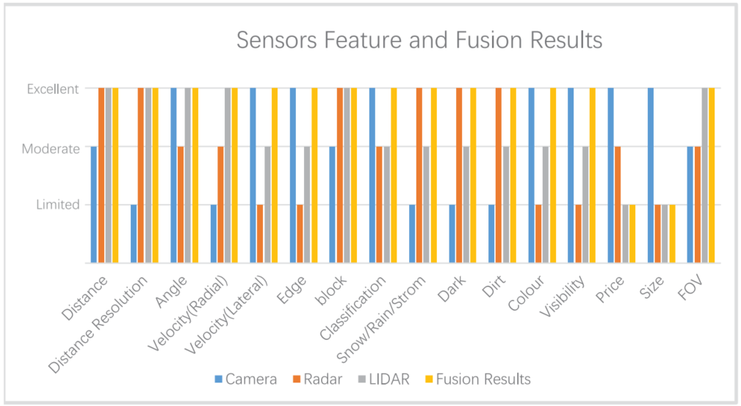

Figure 2.1 Sensor Feature and Fusion Results at Different Scenarios

sensors including IMU, GPS, Barometric Altimeter and Radio Altimeter for the measurement of vertical height (except IMU only for acceleration) of a UAV. Figure 2.2 shows the block diagram of a UAV with 4 sensors fused together through a filter.

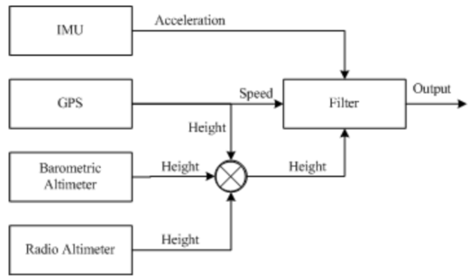

Figure 2.2 Block Diagram of 4 Sensors Fused in a UAV system

### Sensor Fusion Algorithm

Sensor Fusion Algorithm is the place where the data received from two or more sensors are being processed through mathematical operations and gives us the higher quality data from the sensors. (Peng Lu, 2022) believes that until this day, there is no sensor that is guaranteed to provide a 100% accurate and reliable data when it is used individually. There fore multiple sensors with different algorithm are used to attain a more reliable data. (Peng Lu, 2022) had also classified sensor fusion algorithm into 2 classes: Parameter Classification Algorithm and Physical Model Based Classification. Example of techniques classed into Parameter Classification Algorithm are: Weighted Average, Bayesian Estimation, D-S Evidence Theory and Neural Network; whereas example of techniques classed into Physical Model Based Classification are: Kalman Filter. The weighted average technique is known to be the simplest algorithm but still works for many applications.

(Alatise & Hancke, 2020) had made another type of classification for sensor fusion algorithm which are: State Estimation Method and Decision Fusion Method. Table 2.2 shows the description of the two class of algorithms as well as some examples of fusion techniques.

Table 2.2 Classification of Sensor Fusion Algorithm

|  |  |  |
| --- | --- | --- |
| **Class** | **Description** | **Examples** |
| State Estimation | This class involves the uses of current measurement and observation to determine the current state of a system that is continuously changing. | Kalman’s Filter  Particle Filter |
| Decision Fusion | This class combines decision made by many classifiers and make a mutual decision based on the evidence (activity that had happened). | Bayesian Approach  Dempster-Shafer Approach |

(Alatise & Hancke, 2020) also discussed on 2 other filters derived from the Kalman’s Filter which are the: Extended Kalman’s Filter (EKF) and the Unscented Kalman’s Filter (UKF). While Kalman’s Filter typically works only for linear system, EKF is a modified version of Kalman’s filter that is able to work for weakly non-linearised system by linearizing a non-linear system. Whereas UKF is an improved version of the EKF that is able to work on non-linear system with less error compared to EKF but with an increased computational cost. Mentioned in the previous section, (Yang et al., 2020) also used Kalman’s Filter for fusing 4 sensors (IMU, GPS, Barometric Altimeter, Radio Altimeter) and have achieved a greater overall results compared to using single sensor as shown in Figure 2.3.

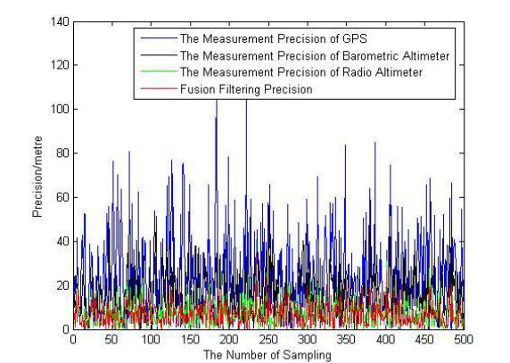

Figure 2.3 Accuracy curve of height measurement in different ways.

There are also some studies for much advanced sensor fusion algorithm such as the study by (Kocić, Jovičić, & Drndarević, 2018) had used PointFusion Network which is one of a Convolutional Neural Network (CNN) technique to fuse multiple optical sensor like the Camera, Radar and LiDAR sensor to form a 3D image of the surrounding of a autonomous vehicle. Figure 2.4 shows how sensor fusion is used for occupancy grid mapping for autonomous vehicle. Other CNN algorithm such as YOLO, SSD, VoxelNet were also used in the study by (Yeong, Velasco-Hernandez, Barry, & Walsh, 2021).

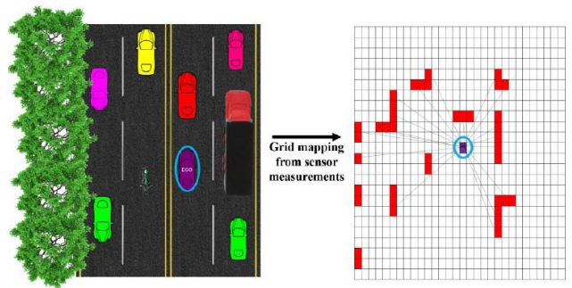

Figure 2.4 Occupancy Grid Mapping

### Quadcopter Assembly

The largest challenge when designing and constructing a quadcopter is to ensure its stability during hovering. The two main reason that will cause a quadcopter to lose stability are: All motors will have slightly different speed in rotation despite same voltage is applied to all due to the variation cause during manufacturing and production; and the external factor like winds, imbalanced distribution of the quadcopter that cause one side to be heavier than the other. However, a quick and simple solution to that is to use a PID controller for each motor. A study by (Sumantri, Tamami, Nuraga, & Kurniawan, 2020) had used an STM32 controller as a PID Controller together with MPU6050 to measure the tilt angle and balance the quadcopter. The prototype of the controller circuit is shown in Figure 2.5.

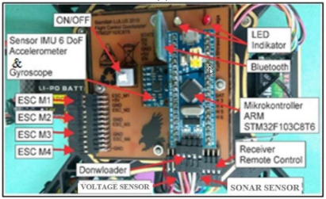

Figure 2.5 Prototype of Controller Circuit using STM32

Another study done by (Tagay, Omar, & Ali, 2021) also found to use a similar technique for controlling the quadcopter stability. However instead of using a STM32, it uses an Arduino Uno-R3 as the PID Controller. Figure 2.6 shows the schematic diagram of the circuit.

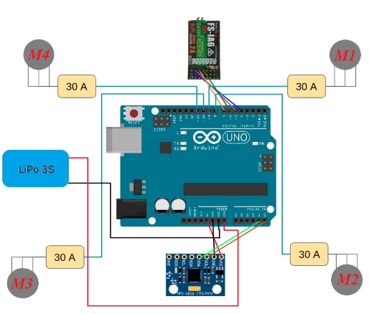

Figure 2.6 Schematics of Controller Circuit using Arduino

## Research Gap

There have been a lot of research on various types of sensor configuration, sensor fusion algorithm, and studies on quadcopter assembly. Many researches had done a great job obtaining a positive result from the sensor fusion technique. However, the main limitation from all researches is that none of the research had shown the third advantages of sensor fusion mentioned in Chapter 1 that is “Increase Coverage Area of Sensor”. Most of the literature found had tackled on the first two advantages which are: “Increasing Quality and Reliability of Measured Data” and “Provides Estimations to Parameters Outside Sensor’s Sensing Ability”. Hence for this project, sensors with shorter effective range of measurement will be selected to see if sensor fusion will be able to improve the data quality if the quadcopter is outside the range of measurement of the sensors.

Besides, some sensors mentioned in the literature above are not very common in the market like the Radio Altimeter or is too highly priced like camera. Furthermore, the sensor fusion algorithm used in some literatures are too computational extensive that may not be suitable for a small microcontroller like ATTiny45/48. In this project, we will also look for a cheaper option for sensor configuration as well as suitable sensor fusion algorithm that is optimum for a simple and cheap microcontroller.

## Summary

The literature review for this paper is done with three main scope which are: Sensors, Sensor Fusion Algorithm and Quadcopter Assembly. The literature review on sensor had scoped down the types of sensors suitable for measuring the height of a quadcopter. Meanwhile, the literature review on sensor fusion algorithm had shown many types of sensor fusion algorithm that are very commonly used in UAVs and even autonomous driving. Finally, the literature from Quadcopter Assembly also gives some idea on how to ensure the stability of a quadcopter which is crucial when hovering. Table 2.3 shows the summary of the literatures used in this chapter.

Table 2.3 Summary of Literature Used in Chapter 2

|  |  |  |  |  |  |  |  |  |
| --- | --- | --- | --- | --- | --- | --- | --- | --- |
| **Sensors and Sensor Fusion Algorithm** | | | | | | | | |
| **Author** | **Sensor Type** | | **Algorithm** | | **Application** | **Functionality** | | **Remarks** |
| (Alatise & Hancke, 2020) | Tactile,  Encoder,  Optical,  Heading,  Vision-Based,  Active-Ranging | | Kalman,  Particle,  Bayesian Network,  Dempter-Shafer | | Autonomous Mobile Robot | Localization & Navigation | | This literature shows the suitable algorithm for different sensor combination |
| (Kocić et al., 2018) | Camera, Radar, Lidar | | PointFusion Network (CNN) | | Autonomous Vehicles | Localization & Mapping | | This literature uses CNN approach to fuse data and form 3D images |
| (Panem, Gaonkar, Rane, Pandit, & Gad, 2016) | Accelerometer,  Gyroscope | | Kalman’s Filter | | Quadcopter | Basic Sensor Data | | This literature aims to transmit data signal over wireless channels for optimum bandwidth utilization |
| (Sabatini & Genovese, 2014) | IMU, Baro-IMU | | Extended Kalman’s Filter | | Vertical Moving Rigid Body | Vertical Velocity,  height | | This literature studies the vertical movement of a rigid body using IMU and barometer fusion using EKF |
| (Wang et al., 2020) | RADAR, Camera, LiDAR, ultrasonic. GPS, IMU, V2X | | Discernible Unit,  Complementary Features, Target Attributes, Multi-source Decision | | Automated Driving | Object Detection and Recognition | | This literature discussed on various sensor configuration and its results. |
| (Yang et al., 2020) | IMU, GPS, Barometric Altimeter, Radio Altimeter | | Kalman’s Filter | | UAVs | Flight Altitude Data | | This literature uses 4 sensors fused using KF to measure the UAV height and provided some equations, then showed fusion result. |
| (Yeong et al., 2021) | Vision Cameras, LiDAR Sensors, Radar sensors | | Deep Learning (YOLO, SSD, VoxelNet, PointNet) | | Autonomous Vehicle | Surrounding Perception | | This literature shows the use of visual sensors for sensor fusion using deep learning algorithm for surrounding perception |
| **Quadcopter Hovering** | | | | | | | | |
| **Author** | | **Sensors** | | **Microcontroller** | | | **Remark** | |
| (Tagay et al., 2021) | | MPU6050 | | Arduino Uno R3 | | | Both studies use the same approach by using PID controller to ensure the stability of the quadcopter during hovering. | |
| (Sumantri et al., 2020) | | MPU6050  HC-SR04 | | STM32F103C8T6 | | |

# RESEARCH METHODOLOGY

## Introduction

In this chapter, the methods that will used for this project will be discussed in detailed. For this project titled ‘Sensor Fusion and PID Control for Quadcopter Hovering’, the work will be divided into 3 parts which are: Sensor Fusion, PID Control and Quadcopter (assembly).

### Proposed Method

#### Research Activities

## Tools and Platforms

## Chapter Summary

# PRELIMINARY RESULTS & ANALYSIS

## The Big Picture

## Analytical Proofs

## Result and Discussion

## Chapter Summary

# CONCLUSION

## Research Outcomes

## Contributions to Knowledge

## Future Works

REFERENCES

Alatise, M. B., & Hancke, G. P. (2020). A Review on Challenges of Autonomous Mobile Robot and Sensor Fusion Methods. *IEEE Access, 8*, 39830-39846. doi:10.1109/ACCESS.2020.2975643

Chu, Y., & Cetin, K. (2022). Sensing systems for smart building occupant-centric operation. In (pp. 431-461).

Herbert. (2023). How Automation Helps Reduce Human Error and Improves Data Quality. Retrieved from <https://trdsf.com/blogs/news/how-automation-helps-reduce-human-error-and-improves-data-quality>

IWM. (n.d). A Brief History of Drones. Retrieved from <https://www.iwm.org.uk/history/a-brief-history-of-drones>

Kocić, J., Jovičić, N., & Drndarević, V. (2018, 20-21 Nov. 2018). *Sensors and Sensor Fusion in Autonomous Vehicles.* Paper presented at the 2018 26th Telecommunications Forum (TELFOR).

Manuel, E. H. K. a. N. (2020, February 17). Automation and Adaptability: How Malaysia Can Navigate the Future of Work.

Panem, C., Gaonkar, A. A., Rane, U. V., Pandit, A. B., & Gad, R. S. (2016, 3-5 March 2016). *Sensors data fusion architecture over MIMO: Case study of quad copter.* Paper presented at the 2016 International Conference on Electrical, Electronics, and Optimization Techniques (ICEEOT).

Peng Lu, F. D. (2022). A Study on Multi-Sensor Data Fusion Algorithm. *Journal of Advances in Artificial Life Robotics, 2(4)*, 195-200.

Research, P. (2022). Autonomous Vehicle Market. Retrieved from <https://www.precedenceresearch.com/autonomous-vehicle-market#:~:text=The%20global%20autonomous%20vehicle%20market,USD%2036.4%20billion%20in%202022>.

Sabatini, A. M., & Genovese, V. (2014). A Sensor Fusion Method for Tracking Vertical Velocity and Height Based on Inertial and Barometric Altimeter Measurements. *Sensors, 14*(8), 13324-13347. Retrieved from <https://www.mdpi.com/1424-8220/14/8/13324>

Sasiadek, J. Z. (2002). Sensor Fusion. *Annual Reviews in Control, 26*(2).

Sumantri, B., Tamami, N., Nuraga, Y. B., & Kurniawan, B. (2020, 29-30 Sept. 2020). *Development of a Low-Cost Embedded Flight Controller for Quadcopter.* Paper presented at the 2020 International Electronics Symposium (IES).

Tagay, A., Omar, A., & Ali, M. H. (2021). Development of control algorithm for a quadcopter. *Procedia Computer Science, 179*, 242-251. doi:<https://doi.org/10.1016/j.procs.2021.01.003>

Wang, Z., Wu, Y., & Niu, Q. (2020). Multi-Sensor Fusion in Automated Driving: A Survey. *IEEE Access, 8*, 2847-2868. doi:10.1109/ACCESS.2019.2962554

Yang, J., Qian, B., Zhang, E., & Qu, K. (2020). UAV Altitude Measurement Method Based on Data Fusion and Kalman Filter. *Journal of Physics: Conference Series, 1631*(1), 012094. doi:10.1088/1742-6596/1631/1/012094

Yeong, D. J., Velasco-Hernandez, G., Barry, J., & Walsh, J. (2021). Sensor and Sensor Fusion Technology in Autonomous Vehicles: A Review. *Sensors, 21*(6), 2140. Retrieved from <https://www.mdpi.com/1424-8220/21/6/2140>